Resolving Information Content Entities
A single instance of information content entity can depend on multiple instances of information bearing entity. For example, the content of a document can reside simultaneously in multiple copies of that document, and in various mediums. Likewise, a single name or identifier can be reproduced in many physical objects (written on a driver’s license, a social security card, a nametag, etc.). Typically, a person only has one name, but that name (content) can be found in many particular physical tokens.
This means—providing sufficient entity resolution—that many instances of information content entity would be resolved to a single resource with a single URI. For example, if John Doe’s name appears in multiple databases, then a correctly resolved RDF graph that integrates those databases would contain exactly one node representing the information content of John Doe’s name. That node would link to multiple nodes representing each unique physical bearer of John Doe’s name.
This raises the question of under what conditions information content entities should be resolved to a single OWL/RDF individual. The answer is: Whenever the content is identical, that content is a single instance of information content entity. Thus, the origin of the content is irrelevant to whether the same content is being captured. For example, if two doctors separately determine that John Doe weighs 150lbs, then the content they record is identical, even though these events occur at two different times and places. By contrast, if one doctor measures the weight incorrectly, then different information content is generated.

Annotating without Provenance
In some situations, users may wish to link instances of information content entity to values without tracking provenance. To meet this need, the CCO introduces an annotation property, is_tokenized_by, which links literal values directly to instances of information content entity.
information content entity is_tokenized_by Literal
The following figure represents these two ways of modeling the fact that a person has the name “John Doe”. In the first, the provenance of the data value “John Doe” is tracked by means of an information bearing entity and the has_text_value relation. In the second, the provenance is ignored, and the information content entity is simply annotated with the value by means of the is_tokenized_by relation.

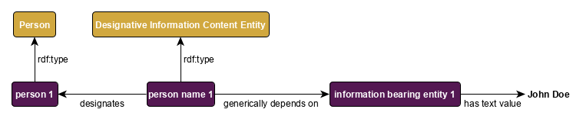

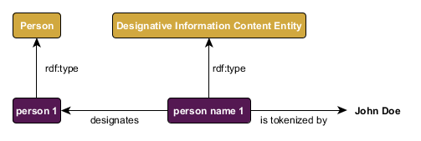
Figure 3: Tracking provenance vs. merely annotating.

Types of Information
An information content entity is linked to the entity that information is about by means of the is_about property (see “An Overview of the Common Core Ontologies,” Section 4.1). This property has three subproperties, each of which represents a different way information can be about the subject of that information: describes, prescribes, and designates. The describes relation is used for information such as reports and representations (e.g., images and court transcripts), the prescribes relation is used for information such as plans and artifact specifications, and the designates relation is used for information such as names and other identifiers.

information content entity describes entity
entity described_by information content entity

information content entity prescribes entity
entity prescribed_by information content entity

information content entity designates entity
entity designated_by information content entity

The Information Entity Ontology also defines subclasses of information content entity which correspond to each of these three primary relations: descriptive information content entity, directive information content entity, and designative information content entity.

Descriptions, Measurements, and Measurement Units
The class descriptive information content entity is used to represent information that is a measurement or representation of some portion of reality. More specific kinds of descriptive information are defined as subclasses, the most important of which are those that represent measurement information.
The class measurement information content entity divides into four main subclasses, each of which represents a different kind of measurement:
Class Name | Description | Example
ratio measurement information content entity | Quantitative measurements with a true-zero value. | Temperature in Kelvin.
interval measurement information content entity | Quantitative measurements with no true-zero value. | Temperature in Fahrenheit, Celsius.
ordinal measurement information content entity | Measurements of entities into rank orders. | Max and min temperature for a given day.
nominal measurement information content entity | Groupings of entities according to some shared (possibly arbitrary) characteristic. | Temperature categorized as “hot” and “cold”.

Strictly speaking, every instance of measurement information content entity is neutral with respect to measurement units. The specific subclasses of measurement information content entity mentioned above capture only the scale that is used (e.g., ratio, interval), but not the unit of measurement (e.g., Kelvin, Fahrenheit). For example, measurements in terms of Fahrenheit and Celsius use the same scale (interval), but different measurement units. By contrast, measurements in terms of Kelvin use not only a different measurement unit, but also a different measurement scale, and so a different type of measurement information content entity.
Further subclasses of measurement information content entity, whose instances can span two or more scales, are based on what is measured or how it is measured:
Class Name | Description | Example
deviation measurement information content entity | Measurement of the extent to which an entity conforms to how it is expected or supposed to be. | A missile impact’s deviation from its target location.
estimate information content entity | Measurement of an entity based on partial information about that entity or an appropriately similar entity. | Estimate of a house’s cost based on similar houses.
probability measurement information content entity | Measurement of the likelihood that a process or process aggregate occurs. | The likelihood of a die landing on 6.
reliability measurement information content entity | Measurement of the extent to which an entity can consistently produce an outcome. | The reliability of a sensor.
veracity measurement information content entity | Measurement of the extent to which a description conforms to the reality it describes. | The veracity of an intelligence document.

Thus, for example, a veracity measurement information content entity could be a nominal measurement information content entity (e.g., true or false), an ordinal measurement information content entity (e.g., more or less veridical), or a ratio measurement information content entity (e.g., 0 to 1).
The CCO class measurement unit and its subclasses are used to represent various general types of measurement units. However, note that specific measurement units (e.g., Fahrenheit, inch, kilometers per hour) are represented in CCO as individuals, not classes. Thus, examples of subclasses of measurement unit include measurement unit of temperature, measurement unit of length, and measurement unit of speed, whereas instances of these classes would be Fahrenheit, inch, and kilometers per hour, respectively.
Instances of the class measurement unit are linked only to instances of information bearing entity, not information content entity. Thus, a measurement of some temperature in Fahrenheit would be represented in a graph such as the following:
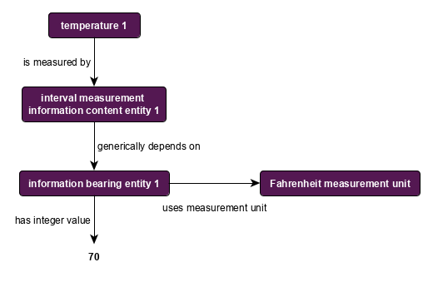
Figure 4: Relationship between measurement information and measurement unit.
Note also that all literal values for temperatures measured according to the Fahrenheit scale should use the same instance of Fahrenheit measurement unit.

Names and Identifiers
The class designative information content entity is used to represent information that names or identifies some entity. Its two most prominent subclasses are designative name, which is used for natural language names (e.g., John Doe, the United States), and code identifier, which is used for designators that are encoded for special purposes (e.g., social security numbers, country codes). Other subclasses include barcode, arbitrary identifier, and site identifier.

